MED D - Over/Under the Benchmark

Overview
Determining Over/Under the Benchmark
Related Documents

Description: This document is used by the MED D Customer Care Representative (CCR) in order to determine if a plan premium in a region is over or under the benchmark.

Overview
The Centers for Medicaid and Medicare Services (CMS) set what is called the median (also known as the benchmark or standard) premium rate. The benchmark premium is the maximum monthly premium that will be paid by CMS for beneficiaries who qualify for Low Income Subsidy (LIS) also known as Extra Help program

A Medicare Part D plan sponsor can set their plan premiums at any rate, but it is best to set plan premiums as close to the benchmark as possible. It is even better (for the beneficiary) if the plan premium is set under the benchmark.

Occasionally, the Medicare Part D Plan sponsor has no choice but to set the plan premium rate over the benchmark (costs in that region can affect this decision).

This document is used by the MED D Customer Care Representative (CCR) in order to determine if a plan premium in a region is over or under the benchmark.

This is important when Auto-Enrolled and Facilitated Enrolled beneficiaries are permanently moving to a new region where SilverScript plan premiums are set higher than the CMS Benchmark.
- Extra Help assists the beneficiary with the Medicare expenses such as copays, coinsurance and plan premiums.
- Regarding plan premiums, CMS will only pay the beneficiary’s plan premium up to the benchmark.
- If the Auto-Enrolled and Facilitated Enrolled beneficiary is moving to a region where the plan premium is over the benchmark, he/she will be disenrolled from their current Medicare Part D plan and will need to enroll in a plan in their new region that is at or under the CMS premium benchmark.

The goal of this document is to assist the CCR with determining if a plan premium is set over or under the CMS benchmark for plan premiums.

Top of the Document

Determining Over/Under the Benchmark

When an LIS beneficiary calls regarding an address change, the CCR must determine if the beneficiary is moving to a region where the plan premium is set over the benchmark. In order to determine if the plan premium is set over the benchmark, the CCR will:
Step | Action
1 | - Navigate to the MED D Inquiry tab.  - Click on the Plan Details tab.  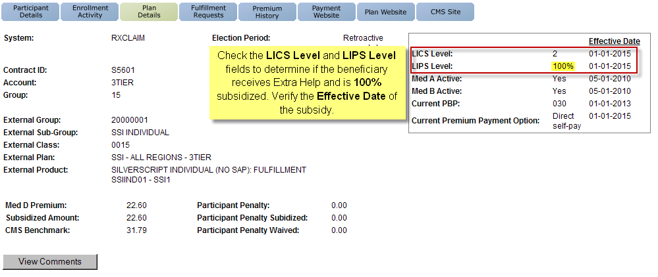  Result: The Plan Details screen will display.  - Check the following fields to verify that the Over the Benchmark process applies to the beneficiary:  - LICS Level: Indicates that the beneficiary receives Extra Help at some level  - LIPS Level: 100% indiciates the beneficiary is fully subsidized depending on Plan selected.  - Effective Date: Verifies whether the Extra Help is still active.
1 | Does the beneficiary have 100% subsidized LIS? |  | Then…
1 | Yes |  | Proceed to the next step.
1 | No |  | Complete the Address Change.  Refer to MED D - Address Changes and Out of Area (OOA).
2 | Refer to the following documents to determine if the beneficiary is Over the Benchmark:  - MED D - 2024 Readiness Plan Design Reference  - MED D - 2023 Readiness Plan Design Reference
2 | If beneficiary is… |  | Then…
2 | Over the Benchmark |  | Will this move be permanent?
2 |  |  | If… | Then…
2 |  |  | Yes | - Since you are moving to an area where SilverScript does not provide a Medicare Part D plan with premiums fully covered by Extra Help, we will need to ask Medicare to disenroll you from SilverScript beginning (first of the following month from the day the beneficiary called).  - It is important that you contact Medicare to choose and join a plan which serves your new address at a plan premium which is fully covered by Extra Help.  - If you choose to enroll in a SilverScript plan in your new service area, you will be responsible for paying the difference of your premium that is over the benchmark.  - Do you wish to remain in a SilverScript plan?
2 |  |  | Yes | If… | Then…
2 |  |  | Yes | Yes | Proceed to Step 3.
2 |  |  | Yes | No | - Mr. /Ms. <beneficiary’s first and last name>, thank you for calling to let us know of your change of address.  - Since you are now moving to a state where SilverScript’s premiums are above the regional premium amount Medicare will pay, and Medicare provides for your premium to be fully subsidized, we need to inform you that we will be disenrolling you effective the 1st of ___________.  - You can evaluate other Medicare options by going online and visiting www.Medicare.gov or refer to your Medicare & You Handbook for available plans in your new area.  - You may also call Medicare at 1-800-MEDICARE (1-800-633-4227), 24 hours a day, 7 days a week.  - TTY users should call 1-877-486-2048.  CCR Process Note: Complete the Permanent Address Change.  Refer to MED D - Address Changes and Out of Area (OOA).  Proceed to Step 5.
2 |  |  | No | - Medicare guidance allows you to live away from your permanent address for no more than 12 months.  - If you find that this will become a permanent move, please contact us again.  CCR Process Note: Complete the Temporary Mailing Address Change. Refer to MED D - Address Changes and Out of Area (OOA).  Proceed to Step 5.
2 | Under the Benchmark |  | Complete the Address Change.  Refer to MED D - Address Changes and Out of Area (OOA).  Proceed to Step 5.
3 | Navigate to the Participant Details screen under the MED D Inquiry tab.  Locate the Auto Enrolled field.  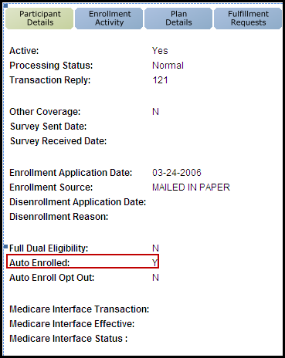
3 | If the Auto Enrolled indicates… | Then…
3 | Y | Because you were enrolled into our plan by CMS, and are choosing to remain in a plan with premiums over the benchmark, you will no longer be auto-enrolled into a plan by CMS.  Proceed to the next step.
3 | N | Proceed to the next step.
4 | - Mr. /Ms. <beneficiary’s first and last name>, since you will be moving to a state where SilverScript’s premiums are above the regional premium amount Medicare will pay. You will be responsible for paying the difference between the premium and the benchmark.  - If you are satisfied with your plan, you will need to complete a new application to remain enrolled in SilverScript.  - However, should you decide to change plans in the future, you will need to select a new plan and submit an enrollment with them at that time.  Note: LIS beneficiaries can change their plan once per calendar quarter during the first nine months of the year or during the annual election period.  - Do you still wish to remain in a SilverScript plan?
4 | If… | Then…
4 | Yes | Per CMS guidance, we must disenroll you from your current area and immediately after I complete that request, I will request an enrollment for you to be effective the first of the following month for you to have continued coverage.
4 | No | - I have sent the disenrollment request.  - Please keep in mind that this will take effect the first of __________.  - Moving to a new service area deems you eligible for a Special Enrollment Period allowing you 60 days to choose a new plan.  - It is important that you contact Medicare to choose and join a plan which serves your new address at a plan premium which is fully covered by Extra Help.  - You can evaluate other Medicare options by going online and visiting www.Medicare.gov or refer to your Medicare & You Handbook for available plans in your new area.  - You may also call Medicare at 1-800-MEDICARE (1-800-633-4227), 24 hours a day, 7 days a week.  - TTY users should call 1-877-486-2048.  CCR Process Note: The disenrollment request will take effect the first of the following month from the day the beneficiary is calling.  Proceed to Step 5.
5 | Ask if there are any other benefit questions.
5 | If… | Then…
5 | Yes | Address any benefit issues.
5 | No | Document and close the call according to current policies and procedures.  Refer to MED D - Call Documentation  Log Activity  1003 = Plan Design Education  Resolution Time  Involuntary Disenrollment = 4 business days  Enrollment = 1st of the month following the day they call in to enroll

Top of the Document

Related Documents
Grievance Standard Verbiage (for use in Discussion with Beneficiary) section in MED D - Grievances Index

Parent SOP: CALL-0048: Medicare Part D Customer Care Call Center Requirements-CVS Caremark Part D Services, L.L.C.
Abbreviations/Definitions: Abbreviations / Definitions

Top of the Document
Not to Be Reproduced or Disclosed to Others without Prior Written Approval
ELECTRONIC DATA = OFFICIAL VERSION - PAPER COPY = INFORMATIONAL ONLY

